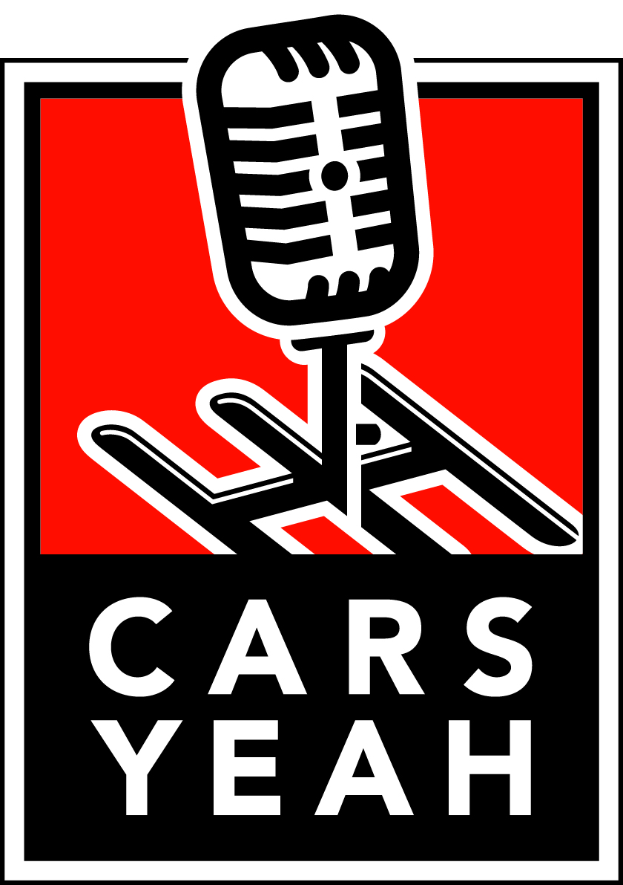

**ADOBE ROAD WINERY**

**AD Spot Copy V2**

May 27 – July 31, 2020

**REDLINE**

What do you do after running a race team for 27 years with over 100 professional wins, multiple wins at the 24 hours of Daytona and a win at LeMans? If you’re Kevin Buckler, Racer and The Racing Group’s Team Owner you create Adobe Road Winery. Located in Petaluma California, he and his team have created a winning combination with The Racing Series. Four ultra-premium red wine blends are in a class of their own. Like racing these wines comprise of art, precision, engineering, science, and a whole lotta fun. You can choose from four blends titles: REDLINE, APEX, SHIFT, and THE 24. Today I’m going to tell you about REDLINE. It is a rich and complex blend delivering a taste of ripe blackberries, black cherry, licorice, and a hint of toasty oak. An added very cool option is that it features the world’s first interactive wine label… when you pour the wine the three-dimensional tachometer hits the redline.

The Racing Series is a killer gift for the automotive enthusiast in your life and I have a deal for you. Use the Code CARSYEAH, all one word and all caps at checkout and get $10.00 off any purchase of wine from The Racing Series. Your wine ships promptly and arrives quickly. Use the Code CARSYEAH at checkout for $10.00 off your purchase.

There’s always a seat at the table for excellence with The Racing Series. Go to Adobe Road Wines.com and use the code CARSYEAH today. (wine cork pop) Cheers!

_____________________________________

**APEX**

What do you do after running a race team for 27 years with over 100 podiums, multiple Daytona wins and wins at LeMans? Racer and The Racers Group team owner Kevin Buckler founded Adobe Road Winery. Located in Petaluma California, he and his team have created a winning combination with The Racing Series. Four ultra-premium red wine blends are in a class of their own. Like racing these wines comprise of art, precision, engineering, science, and a whole lotta fun. You can choose from four blends titles: REDLINE, APEX, SHIFT, and THE 24. Today I’m going to tell you about APEX. It is a rich and complex blend of Cabernet Sauvignon, Syrah, and Cabernet Franc. This blend is a showcase of perfection and hits the apex with its full-bodied smooth finish. An added very cool option is a label with a multi-dimensional rumble strip apex, reminiscent of turn four at Laguna Seca.

The Racing Series is a spectacular gift for the automotive enthusiast in your life and I have a deal for you. Use the Code CARSYEAH, all one word and all caps at checkout and get $10.00 off any purchase of wine from The Racing Series. Your wine ships promptly and arrives quickly. Use the Code CARSYEAH at checkout for $10.00 off your purchase.

There’s always a seat at the table for excellence with The Racing Series. Go to Adobe Road Wines.com and use the code CARSYEAH today. (wine cork pop) Cheers!

_____________________________________

**SHIFT**

What do you do after running a race team for 27 years with over 100 podiums, multiple Daytona wins and wins at LeMans? Racer and The Racers Group team owner Kevin Buckler founded Adobe Road Winery. Located in Petaluma California, he and his team have created a winning combination with The Racing Series. Four ultra-premium red wine blends are in a class of their own. Like racing these wines comprise of art, precision, engineering, science, and a whole lotta fun. You can choose from four blends titles: REDLINE, APEX, SHIFT, and THE 24. Today I’m going to tell you about SHIFT. This wine was awarded 93 points by Robert Parker’s Wine Advocate. It is balanced and spicy with dark blueberries and a cigar aroma. The unique bottle shape features a vintage inspired metal gated shifter backed with carbon fiber and the cork is topped with a five-speed shift knob. There will be a battle as to who gets to keep the cork on this one.

The Racing Series is a delicious gift for the automotive enthusiast in your life and I have a deal for you. Use the Code CARSYEAH, all one word and all caps at checkout and get $10.00 off any purchase of wine from The Racing Series. Your wine ships promptly and arrives quickly. Use the Code CARSYEAH at checkout for $10.00 off your purchase.

There’s always a seat at the table for excellence with The Racing Series. Go to Adobe Road Wines.com and use the code CARSYEAH today. (wine cork pop) Cheers!

____________________________________

**THE 24**

What do you do after running a race team for 27 years with over 100 podiums, multiple Daytona wins and wins at LeMans? Racer and The Racers Group team owner Kevin Buckler founded Adobe Road Winery. Located in Petaluma California, he and his team have created a winning combination with The Racing Series. Four ultra-premium red wine blends are in a class of their own. Like racing these wines comprise of art, precision, engineering, science, and a whole lotta fun. You can choose from four blends titles: REDLINE, APEX, SHIFT, and THE 24. Today I’m going to tell you about THE 24. This wine earned 91+ points from Robert Parker’s Wine Advocate. It is a dark, spicy, and velvety blend with ripe blue and black fruit and very smooth tannins. The label features a three-dimensional full metal chronograph, in a bright gold finish that pays homage to the Daytona Rolex winners receive at Le Mans.

The Racing Series is a fantastic gift for the automotive enthusiast in your life and I have a deal for you. Use the Code CARSYEAH, all one word and all caps at checkout and get $10.00 off any purchase of wine from The Racing Series. Your wine ships promptly and arrives quickly. Use the Code CARSYEAH at checkout for $10.00 off your purchase.

There’s always a seat at the table for excellence with The Racing Series. Go to Adobe Road Wines.com and use the code CARSYEAH today. (wine cork pop) Cheers!

____________________________________

**THE RACING SERIES**

Kevin Buckler is a winning Racer and team owner of The Racers Group. He has over 100 professional wins, multiple wins at the 24 hours of Daytona and a win at LeMans. Kevin realized the racing world is about the people and founded Adobe Road Winery. He and his team have created a winning combination with The Racing Series. Four ultra-premium red wine blends are in a class of their own with a racing twist. Just like in racing these wines comprise of art, precision, engineering, science, superb taste, all blended together with a whole lotta fun. There are four carefully crafted blends with race inspired names: REDLINE, APEX, SHIFT, and THE 24. When you purchase all four, you’ll get the entire line up in a beautifully designed gift box. There is a printed description of the blends inside the box lid and every bottle is parked in a protective die-cut placeholder. The bottles feature three dimensional labels and I promise you’ll want to keep them after enjoying these delicious wines. The box is so cool you’ll want to keep it too. The Racing Series is a killer gift for the automotive enthusiast in your life and I have a deal for you. Use the Code CARSYEAH, all one word and all caps at checkout and get $10.00 off any purchase of wine from The Racing Series. Your wine ships promptly and arrives quickly. Use the Code CARSYEAH at checkout for $10.00 off your purchase.

There’s always a seat at the table for excellence with The Racing Series. Go to Adobe Road Wines.com and use the code CARSYEAH today. (wine cork pop) Cheers!

____________________________________________________________________

**AD Spot Copy**

May 19 – July 31, 2020

**REDLINE**

What do you do after running a race team for 27 years with over 100 professional wins, multiple wins at the 24 hours of Daytona and a win at LeMans? If you’re Kevin Buckler, Racer and The Racing Group’s Team Owner you create Adobe Road Winery. Located in Petaluma California, he and his team have created a winning combination with The Racing Series. Four ultra-premium red wine blends are in a class of their own. Like racing these wines comprise of art, precision, engineering, science, and a whole lotta fun. You can choose from four blends titles: REDLINE, APEX, SHIFT, and THE 24. Today I’m going to tell you about REDLINE. It is a rich and complex blend delivering a taste of ripe blackberries, black cherry, licorice, and a hint of toasty oak. An added very cool option is that it features the world’s first interactive wine label… when you pour the wine the three-dimensional tachometer hits the redline.

The Racing Series is a killer gift for the automotive enthusiast in your life and I have a deal for you. Use the Code CARSYEAH and get a flat shipping rate of $10. Your wine ships promptly and arrives quickly. Use the Code CARSYEAH at checkout.

There’s always a seat at the table for excellence with The Racing Series. Go to Adobe Road Wines . com and use the code CARSYEAH today. (wine cork pop) Cheers!

_____________________________________

**APEX**

What do you do after running a race team for 27 years with over 100 podiums, multiple Daytona wins and wins at LeMans? Racer and The Racers Group team owner Kevin Buckler founded Adobe Road Winery. Located in Petaluma California, he and his team have created a winning combination with The Racing Series. Four ultra-premium red wine blends are in a class of their own. Like racing these wines comprise of art, precision, engineering, science, and a whole lotta fun. You can choose from four blends titles: REDLINE, APEX, SHIFT, and THE 24. Today I’m going to tell you about APEX. It is a rich and complex blend of Cabernet Sauvignon, Syrah, and Cabernet Franc. This blend is a showcase of perfection and hits the apex with its full-bodied smooth finish. An added very cool option is a label with a multi-dimensional rumble strip apex, reminiscent of turn four at Laguna Seca.

The Racing Series is a killer gift for the automotive enthusiast in your life and I have a deal for you. Use the Code CARSYEAH and get a flat shipping rate of $10. Your wine ships promptly and arrives quickly. Use the Code CARSYEAH at checkout.

There’s always a seat at the table for excellence with The Racing Series. Go to Adobe Road Wines . com and use the code CARSYEAH today. (wine cork pop) Cheers!

_____________________________________

**SHIFT**

What do you do after running a race team for 27 years with over 100 podiums, multiple Daytona wins and wins at LeMans? Racer and The Racers Group team owner Kevin Buckler founded Adobe Road Winery. Located in Petaluma California, he and his team have created a winning combination with The Racing Series. Four ultra-premium red wine blends are in a class of their own. Like racing these wines comprise of art, precision, engineering, science, and a whole lotta fun. You can choose from four blends titles: REDLINE, APEX, SHIFT, and THE 24. Today I’m going to tell you about SHIFT. This wine was awarded 93 points by Robert Parker’s Wine Advocate. It is balanced and spicy with dark blueberries and a cigar aroma. The unique bottle shape features a vintage inspired metal gated shifter backed with carbon fiber and the cork is topped with a five-speed shift knob. There will be a battle as to who gets to keep the cork on this one.

The Racing Series is a killer gift for the automotive enthusiast in your life and I have a deal for you. Use the Code CARSYEAH and get a flat shipping rate of $10. Your wine ships promptly and arrives quickly. Use the Code CARSYEAH at checkout.

There’s always a seat at the table for excellence with The Racing Series. Go to Adobe Road Wines . com and use the code CARSYEAH today. (wine cork pop) Cheers!

____________________________________

**THE 24**

What do you do after running a race team for 27 years with over 100 podiums, multiple Daytona wins and wins at LeMans? Racer and The Racers Group team owner Kevin Buckler founded Adobe Road Winery. Located in Petaluma California, he and his team have created a winning combination with The Racing Series. Four ultra-premium red wine blends are in a class of their own. Like racing these wines comprise of art, precision, engineering, science, and a whole lotta fun. You can choose from four blends titles: REDLINE, APEX, SHIFT, and THE 24. Today I’m going to tell you about THE 24. This wine earned 91+ points from Robert Parker’s Wine Advocate. It is a dark, spicy, and velvety blend with ripe blue and black fruit and very smooth tannins. The label features a three-dimensional full metal chronograph, in a bright gold finish that pays homage to the Daytona Rolex winners receive at Le Mans.

The Racing Series is a killer gift for the automotive enthusiast in your life and I have a deal for you. Use the Code CARSYEAH and get a flat shipping rate of $10. Your wine ships promptly and arrives quickly. Use the Code CARSYEAH at checkout.

There’s always a seat at the table for excellence with The Racing Series. Go to Adobe Road Wines . com and use the code CARSYEAH today. (wine cork pop) Cheers!

____________________________________

**THE RACING SERIES**

Kevin Buckler is a winning Racer and team owner of The Racers Group. He has over 100 professional wins, multiple wins at the 24 hours of Daytona and a win at LeMans. Kevin realized the racing world is about the people and founded Adobe Road Winery. He and his team have created a winning combination with The Racing Series. Four ultra-premium red wine blends are in a class of their own with a racing twist. Just like in racing these wines comprise of art, precision, engineering, science, superb taste, all blended together with a whole lotta fun. There are four carefully crafted blends with race inspired names: REDLINE, APEX, SHIFT, and THE 24. When you purchase all four, you’ll get the entire line up in a beautifully designed gift box. There is a printed description of the blends inside the box lid and every bottle is parked in a protective die-cut placeholder. The bottles feature three dimensional labels and I promise you’ll want to keep them after enjoying these delicious wines. The box is so cool you’ll want to keep it too. The Racing Series is a killer gift for the automotive enthusiast in your life and I have a deal for you. Use the Code CARSYEAH and get a flat shipping rate of $10. Your wine ships promptly and arrives quickly. Use the Code CARSYEAH at checkout.

There’s always a seat at the table for excellence with The Racing Series. Go to Adobe Road Wines . com and use the code CARSYEAH today. (wine cork pop) Cheers!